Hotel Booking Analysis

The objective of this document is to analyze and present the insights derived from our data analysis. We begin with a comprehensive understanding of the data required for the analysis. This project involves using a dataset for MySQL, which we imported directly into Power BI. Upon loading the data into Power BI, we evaluated its cleanliness and identified any necessary data cleaning procedures. The data was generally well-maintained, except for an empty unnamed column in the hotel booking table. We addressed this by deleting the unnecessary column using Power Query.

To understand the relationship and differentiating fact and query table, we utilized Power BI’s model view feature.

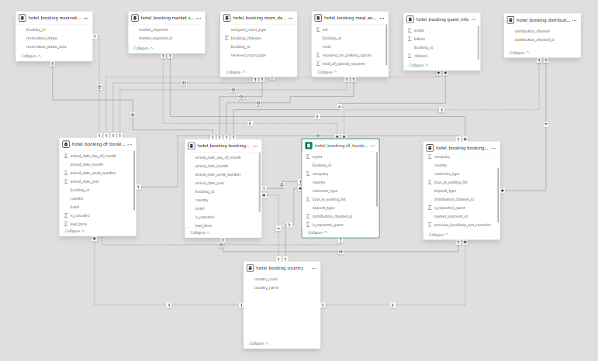

# MECE BREAKDOWN OF KEY INSIGHTS

Once we loaded, cleansed, modelled and Analyzed the data now we could proceed to observe any KPI’s or predictions we could infer as per our own observations.

As KPI’s could be of 100’s of possibilities we could simply classify all the key metrics and then to quote

### Quantitative KPIs.

### Efficiency metrics.

### Top performers.

### Statistical.

### Underperformers.

Once we have divided our expected and required KPIs we could define some of the KPIs and the explanation is as follows.

## Quantitative

Quantitative KPIs includes all the basic metrics, which gives us the overview of the current situation of the business or bookings.

The following can be some of the examples of it.

1. Number of total bookings.
2. Number of bookings that were not cancelled.
3. Total number of bookings from existing customer’s.
4. Number of bookings/month.

## Efficiency metrics

After getting an overview of current situation of business we could now analyze metrics that defines the efficiency of hotel bookings.

For instance,

1. Average awaiting days.
2. Total special requests.
3. Number of customer who required a parking space.
4. Preferred room type.
5. Total Refundable deposits.

These metric either directly or indirectly improves the hotel efficiency to handle customer requirement and to deliver excellent customer experience.

## Top performers

These numbers can be key to analyze the performance, opportunities and focus on the key aspect of business. For instance, if there is any special occasions or vacations, the top performing branches could be given more priority and made ready for all the upcoming demand.

Let us define some of the metrics

1. Top country to have maximum bookings.
2. Which customer_type has the maximum bookings.
3. Market segment with maximum bookings.
4. Customer who have maximum bookings.

The top performers help us realize what are our strengths and where should be our focus remain. Now we could further enhance our understanding and uncover major insights using statistical analysis.

## Statistical

Statistical measurements are important part of any research and analyzation, these statistics help us recognize any major variation or anomalies. Some of the KPIs are

1. Standard deviation of booking through a year.
2. Average lead time.
3. Co-relation between month and bookings.
4. Co-efficient of variance number of days reserved.
5. Skewness of no. of bookings throughout the year.

And many more,

These are important to take data-driven decision and also to infer future predictions

## Underperformers

These numbers give us data about aspects of improvements or underperformance, which can be crucial to detect the factors affecting the overall performance and take necessary actions,

some of the aspects of negative readings are,

1. Number of reservations that were cancelled.
2. Market segment with Lowest booking.
3. Number of customers who didn’t showed up.
4. Churn rate.
5. Max Await time.
6. Country with lowest booking.

# Conclusion

These KPI’s can be some of the indicators of performance of a hotel booking company based on the data which was used to analyze, these KPIs can be picked depending upon the need of business operations and predictions requirements.

In the end, KPIs can be more complex and robust, but the aspect of this document is to exhaustively define different types of KPIs and their application.

With the help of this analysis one can development more ambience indicator combining or deriving from some of key basic KPIs.